Reader’s Guide to the Budget

The City of Fernandina Beach budget document is intended to provide information for a variety of purposes for different groups of users. It serves as a policy document, financial plan, and operating guide for City services. The Reader’s Guide provides assistance in using the 2016-2017 City of Fernandina Beach’s Budget document. The primary goal is to facilitate the understanding of the budget document and to increase its effectiveness as a communications device between the City of Fernandina Beach’s government and its citizens. In this section, readers can find answers to frequently asked questions and be directed to other sections of the document to find information.

General Information About Fernandina Beach

Historical Background

The City of Fernandina Beach is a seaside community with a rich history located on beautiful Amelia Island.

The Timucuan Indians were among the first inhabitants of the area. Then in the 1500’s the first visitors from Europe discovered Fernandina Beach.

Since that time, eight different flags have flown over the City. The French were the first European visitors to take control of the island in 1562. They were defeated by the Spanish in 1565, who named the island “Santa Maria”. The Spanish and the English fought over control of the area for many years. In 1702, the Spanish settlement was destroyed and James Edward Oglethorpe (Georgia's founder and colonial governor) changed the name of the island to Amelia after the daughter of King George II.

At the end of the American War of Independence (1783), an international treaty returned the province from Britain to Spain, who then established a provincial governor in St. Augustine. Yet, in 1812, the “Patriots of Amelia Island” overthrew the Spanish and hoisted their flag. A day later their flag was replaced by the American Flag. In 1817, Scottish mercenary Sir Gregor MacGregor over took the island and hoisted the Green Cross of Florida.

Historical Background Continued

Due to lack of funds and men, when Spanish troops approached to reclaim the island, Sir Gregor MacGregor left Jared Irwin and Ruggles Hubbard (two American adventures) in command. Shortly thereafter, Pirate Luis Aury arrived with men and money and claimed the island alongside Irwin and Hubbard for the Mexican Rebels.

Two days before Christmas in 1817 the U.S. Navy temporarily occupied the island and drove Aury off.

In 1819, the U.S. purchased Florida from Spain. In 1821, Florida became a US territory attaining statehood in 1845. So the seven years from 1811-1817, Fernandina was under five of its eight flags. (Spain, Patriot, Green Cross, Mexican Rebel, U.S.). The other flags were those of France, England, and the Confederacy.

Around the turn of the century, Fernandina Beach flourished as a popular playground for tourists. Then as tourism began to move further south, progress slowed. Old Victorian homes and buildings were not replaced but repaired. This left the City a wonderful heritage, including a fifty-block area of downtown which is listed on the National Register of Historic Places.

Today Fernandina Beach is once again a flourishing community. Visitors from all over come to enjoy golf, beaches, historical landmarks, fine restaurants, and beautiful weather.

Description of Government

The form of government of the City of Fernandina Beach is known as the “Commission-Manager Plan.” Under this plan, the Commission has powers to adopt ordinances, approve regulations, and appoint the City Attorney, City Clerk, and City Manager.

The Fernandina Beach City Commission consists of five citizens who are elected at large, who then elect from their own, a Mayor who presides at all meetings of the Commission.

Location of Fernandina Beach

The City of Fernandina Beach is located on the northern end of Amelia Island; this “barrier island” represents the northeastern edge of Nassau County. Amelia Island is situated between the Amelia River to the west and the Atlantic Ocean to the east, with the City of Jacksonville (Duval County) to the south and Camden County, Georgia, to the north.

Location of Fernandina Beach in Nassau County

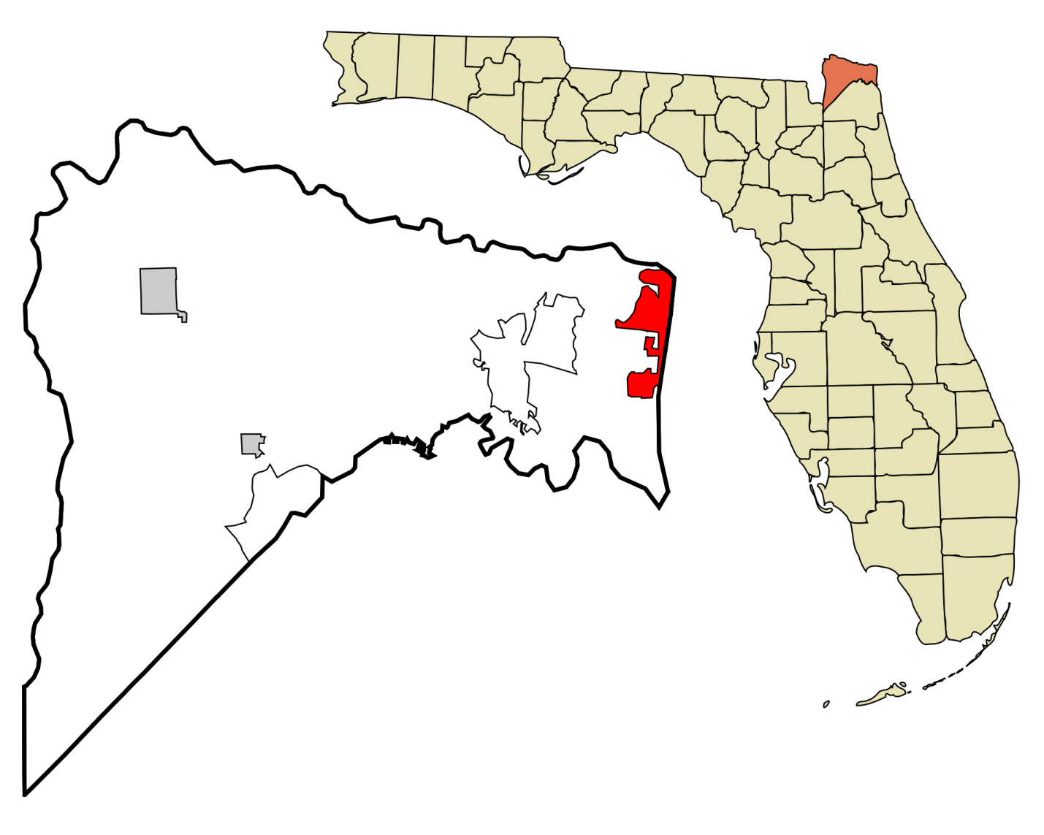
Fernandina Beach
Nassau County
Budget Tab Descriptions

Budget Message | The Budget Message formally transmits the budget to the Mayor, City Commissioners, and citizens. This communication contains summaries of major initiatives within the budget, significant accomplishments, and noteworthy policy issues facing the City.
Statistical Analysis | The Statistical Analysis is a collection, examination, summarization, and interpretation of the City’s quantitative data to discover underlying causes, patterns, relationships, and trends that ultimately assists with goals, initiatives, and improvements.
Budget Summary | Provides revenue and expenditure trends and assumptions with an explanation of major changes for the City’s fiscal year.
General Fund | The General Fund is the largest fund in the City. It is comprised of the many City departments and it supports all services not assigned to the Enterprise or Internal Service fund.
Enterprise Funds | Provides Information used to account for the operations and services of the City.
Special Funds | Provides detail of how funds are used to account for the proceeds of specific revenue sources (other than expendable trusts or major capital projects) that are legally restricted to expenditures for specified purposes.
Debt Service Funds | Provides detail to account for the accumulation of resources for, and the payment of, general long-term and short-term debt principal, interest and related costs.
Capital Projects Funds | Provides detail for capital projects approved for the fiscal year. This section discusses funding sources, debt service, the capital improvements planning cycle, and criteria used to establish priorities.
Internal Service Funds | Provides information used to account for City activities that provide goods and services to other City departments or agencies.
Trust Funds | Pension (and other employee benefit) Trust Funds are used to report resources that are required to be held in trust by the City for the members and beneficiaries of defined benefit plans, defined contribution pension plans, and other employee benefit plans.
Appendix | Provides miscellaneous budget cycle information and policies.
Frequently Asked Question(s):

Question | Refer to Tab(s) | Page(s)
What is the total budget? | Budget Summary | III. 2 – III. 14
What is the City’s millage rate? | Statistical Analysis | II. 5
Where can I find the organizational chart of Fernandina Beach? | Statistical Analysis | II. 2
How many employees does the City employ? | Statistical Analysis  Budget Summary | II. 3  III. 12 – III.13
What is the City’s budget process timeline? | Appendix | XII. 3
What changes are being made? | City Manager’s Budget Message | I. 1
Where the money comes from and where the money goes? | Budget Summary  Revenue Highlights  Expenditure Highlights | III. 15 – III.21
How much money do we have in the reserves? | Budget Summary | III. 2
Where can I find the Fernandina Beach area population? | Statistical Analysis | II. 11
Where are the City’s financial policies? | Appendix | XII. 4
Where can I learn about the capital budget? | City Manager’s Budget Message  Capital Funds | I. 1  VIII. 13
What are the goals of the City of Fernandina Beach? | City Manager’s Budget Message  Capital Funds | I. 1  VIII. 13 – VIII. 24
How much money is available for Capital projects? | Capital Funds | VIII. 8

Glossary

Account – A term used to identify an individual asset, liability, expenditure control,
revenue control, encumbrance control or fund balance.

Ad Valorem Taxes – Property taxes which are computed by applying the millage rate to
the assessed value of property after all exemptions have been subtracted. Property taxes are paid to the various local governments through a single payment to the county tax collector.

Amendment – Change to an adopted budget which may increase or decrease a fund total.

Annual Budget – A budget applicable to a single fiscal year

Appropriation – A legal authorization granted by a legislative body to make expenditures and to incur obligations for specific purposes. An appropriation is usually limited in amount and time it may be expended

Assessed Valuation – County Property Appraiser’s estimation of the fair market value of
real or personal property.

Asset – Resources, owned or held by a government, which have monetary value. Assets may be tangible or intangible and are expressed in terms of cost or some other value.

Audit – A comprehensive review of the manner in which the City’s resources were actually utilized. The main purpose of an audit is to issue an opinion on the fair presentation of the financial statements and to test the controls over the safekeeping of assets while making recommendations for improvement where necessary.

Balanced Budget – All the City’s estimated sources of revenues, including uses of fund balances, equal expenditure appropriations for the fiscal year.

Bond – A written promise to pay a specified sum of money (called the face value or principle amount), at a specified date or dates in the future, i.e. maturity date(s), together with periodic interest at a specified rate. Sometimes, all or a substantial portion of the interest is included in the face value of the security.

Budget – A financial statement listing a governmental agency’s expected income and
expenses for a 12-month period. Florida law requires that governments have a balanced
budget, with expenses not exceeding revenues. A proposed budget is prepared by the
City manager and it becomes formal when adopted by the City Commission. If changes
occur during the year, local governments can transfer funds within a budget or raise fees,
etc., to keep the budget in balance.
Glossary

Budget Hearing – Public Hearing conducted to consider and adopt the annual budget.

Capital Improvement Program (CIP) – Governmental agencies set up five-year programs for
major long term costs such as the purchase of fire trucks, buildings and land. Capital expenses are listed separately from operating expenses within the budget document.

Capital Outlay: - Costs for the purchase or additions to the land, buildings, vehicles or
other equipment with a useful life greater than one year. The asset value must meet or exceed the following thresholds:
Buildings | $5,000 General Fund; $2,500 Enterprise Funds
Building Improvements | $5,000 General Fund; $2,500 Enterprise Funds
Machinery & Equipment | $5,000 General Fund; $2,500 Enterprise Funds
Infrastructure | $5,000

Contingency Fund – Money set aside for emergencies or unexpected expenses that were not anticipated when the budget was being prepared.

Debt – An obligation resulting from the borrowing of money or from the purchase of goods and services.

Debt Limit – The maximum amount of outstanding gross or net debt legally permitted.

Deficit – A term generally applied to the budget as a whole, reflecting real or projected revenue shortages, meaning there are insufficient funds to cover expenses.

Department – An administrative agency of the City having management responsibility for an operation or a group of related services within a functional area.

Enterprise Fund – A fund established to support a single service from which revenues are received from charges for services to fund the delivery of that service.

Expenditures – Decreases in net financial resources. Expenditures include current operating expenses requiring the present or future use of net current assets, debt service, capital outlays, intergovernmental grants, entitlements, and shared revenues.

Fiscal Year – The budget year. A 12-month period to which the Operating Budget applies, at the end of which the City determines its financial position and its results of operations. The City’s fiscal year runs from October 1 – September 30.

Glossary

Franchise Fees – Money collected, usually from a private utility, in exchange for use of a governmental agency’s easements and rights-of-way. Cities and counties authorize the use of these and collect a fee in return.

Full Time Position – Position that qualifies for full city benefits, usually 40 hours.

Fund – A listing within the budget, indicating the revenues and expenditures for a specific category of operation. The largest fund is the General Fund. This fund includes
subcategories that support most of the city’s operation. Other funds include those for sewer and garbage, State and Federal grants, etc.

General Fund – Typically serves as the chief operating fund of a government. The general fund is used to account for all financial resources except those required to be accounted for in another fund.

General Obligation Bond – A general obligation bond is a common type of municipal bond in the United States that is secured by a state or local government's pledge to use legally available resources, including tax revenues, to repay bond holders.

Generally Accepted Accounting Principles (GAAP) – Uniform minimum standards and guidelines for financial accounting and reporting. The primary authoritative body on the application of GAAP to state and local governments in the Governmental Accounting Standards Board (GASB).

Governmental Accounting Standards Board (GASB) – The authoritative accounting and financial reporting standard-setting body for governmental entities.

Governmental Funds – Funds used to account for tax-supported activities. There are seven different types of governmental funds: (1) General Fund; (2) Enterprise Fund; (3) Special Funds; (4) Debt Service Funds; (5) Capital Projects Funds; (6) Internal Service Funds; and (7) Trust Funds

Grant – Contributions by one organization to another for a specific purpose.

Impact Fee – A fee to fund the cost of a new development’s impact on various City services. This fee is charged to those responsible for the new development as a condition for obtaining a building permit.

Infrastructure – Assets that are immovable and of value only to the governmental unit such as drainage and sewer systems
Glossary

Liabilities – Debts or other legal obligations arising out of transactions in the past, which must be liquidated, renewed, or refunded at some future date. This term does not include encumbrances.

Mill – A tax rate of one dollar ($1) per one thousand ($1,000) of taxable property value.

Millage – A figure assigned to each governmental unit with ad valorem taxing authority for use in determining taxes. It determines how much revenue the government will receive from property taxes and how much an individual property owner pays by applying the millage rate to the value of property within the City.

Objective – A simply stated, readily measurable statement of aim or expected accomplishment within the fiscal year. A good statement of objectives should simply be a specific standard of performance for a given program.

Operating Expenses – The costs associated with day-to-day activities of a government not including personal services or capital outlay costs.

Ordinance – A law set forth by a governmental entity, usually a municipal government.

Over Budget – Over budget in revenue means that more income was received than budgeted. Over budget in expenses means costs were more than budgeted figures, and
generally, necessitates that spending must stop or money be transferred into the appropriate account to balance the budget by year-end.

Pay-As-You-Go Basis – A term used to describe a financial policy by which capital outlay is financed from current revenues rather than through borrowing.

Personal Services – Costs for employee salaries, wages and fringe benefits.

Prior Year Carryover – Money not spent on one fiscal year, but carried forward to the
next budget. Cash carried forward can be used to pay operating expenses at the beginning of a fiscal year before tax revenue are collected, or during a fiscal year if
anticipated revenues have not yet been collected.

Proposed Budget - The budget proposed by the City Manager to the City Commission for review and approval.

Recurring Revenues – Revenues that can be expected to be received each year unless
specific action is taken to eliminate the source.
Glossary

Referendum – A question voted on by the citizens of the local government.

Resolution – An expression of a governing body concerning matters of administration,
an expression of a temporary character, or a provision for the disposition of a particular
item of the administrative business of the governing body.

Revenue – Income received by the City from a variety of sources including taxes, fees,
charges for services, grants, borrowing, or other governmental agencies.

Rolled-Back Millage Rate – A tax rate the county property appraiser determines is necessary to give a governmental agency the same amount of property tax dollars it received during the previous budget year.

Special Assessment – A compulsory levy made against certain properties to defray part or all of the cost of a special improvement or service deemed to primarily benefit those properties.

State-Shared Revenue – Money that cities and counties receive from the state. It includes the local share of cigarette taxes, fuel taxes, mobile home license taxes, liquor
taxes and sales taxes based on a distribution formula set by State law.

Statute – A written law enacted by a duly organized and constituted legislative body.

Taxable Valuation – The value of property after all allowable exemptions have been
subtracted; the value on which ad valorem taxes are computed.

Trim Bill – Florida’s Truth in Millage law requires cities to calculate next year’s budget
on the same tax dollars they received during the current fiscal year.

Under Budget – Under budget in expenses means either the agency has been spending at a slower rate than expected, or that expenses were over estimate when the budget was
prepared. Under budget in revenues means that money being collected from the various
sources is not as much as was anticipated; it might necessitate spending adjustments.

User fee – The charging of fees for the use of services such as recreational, sewer and garbage services.

Utility Taxes – Taxes paid to municipalities by users of telecommunication services, electricity, water, natural gas, bottled gas and fuel oil.

Valuation – The dollar value of property assigned by the county property appraiser.
Frequently Used Acronyms

AAC | Airport Advisory Commission
ADA | Americans with Disabilities Act
ALS | Advanced Life Support
ANC | Arts & Culture Nassau
ARC | Atlantic Recreational Center
BOA | Board of Adjustment
BOAF | Building Officials Association of Florida
CDBG | Community Development Block Grant
CDD | Community Development Department
CEAB | Code Enforcement & Appeals Board
CEMP | County Emergency Management Plan
CFPBA | Central Florida Police Benevolent Association
CIP | Capital Improvement Plan
COA | Certificates of Approval
CPI | Coastal Partnership Initiative
CRA | Community Redevelopment Area
DHS | Department of Health Services
DOS | Department of State
DUI | Driving Under the Influence
EMPA | Emergency Management Preparedness and Assistance
EMS | Emergency Medical Services
EPA | Environmental Protection Agency
EPH | Environmental Public Health
ERP | Enterprise Resource Planning
F&B | Food and Beverage
FAA | Federal Aviation Administration
FBIP | Florida Boating Improvement Plan
FBYAC | Fernandina Beach Youth Advisory Committee
FDEP | Florida Department of Environmental Protection
FDOS | Florida Department of State
FDOT | Florida Department of Transportation
FEMA | Federal Emergency Management Agency
FICA | Federal Insurance Contributions Act
FIND | Florida Inland Navigation District
FLUM | Future Land Use Map
FOL | Friends of the Library
FRDAP | Florida Recreation Development Assistance Program
FRPA | Florida Recreation and Parks Association
FT | Full-Time
FTE | Full-Time Equivalent
GAAP | Generally Accepted Accounting Principles
GASB | Governmental Accounting Standards Board
GEPP | General Employees’ Pension Plan
GF | General Fund
GFOA | Government Finance Officers Association
GIS | Geographic Information System
GOB | General Obligation Bond
GOC | Greens & Oversight Committee
HDC | Historic District Council
HRIS | Human Resource Information System
HVAC | Heating, Ventilating, and Air Conditioning
IAFF | International Association of Fire Fighters
IMS | Information Management Services
ISO | Insurance Services Office
IT | Information Technology
LBTR | Local Business Tax Receipt
LDC | Land Development Code
MLK | Martin Luther King
N/A | Not Applicable
NFIP | National Flood Insurance Program
NFPA | National Fire Protection Association
O & M | Operation & Maintenance
OPEB | Other Post-Employment Benefits
PAB | Planning Advisory Board
PCC | Peck Center Committee
PFPP | Board of Trustees Police & Fire Pension Plan
PRAC | Parks & Recreation Advisory Committee
PSA | Public Service Announcements
PT | Part-Time
R/M | Repair/Maintenance
RFI | Request for Information
RFP | Request for Proposal
S | Seasonal
SAFER | Staffing for Adequate Fire and Emergency Response
SBA | Small Business Administration
SEU | Selective Enforcement Unit
SJRWMD | St. Johns River Water Management District
SOP | Standard Operating Procedures
TBD | To Be Determined
TDC | Tourist Development Council
TRC | Technical Review Committee
UB | Utility Billing
UBC | United Brotherhood of Carpenters
UCR | Uniform Crime Report
URL | Uniform Resource Locator
VPN | Virtual Private Network
WFPP | Waterfronts Florida Partnership Program

